Ideation Phase Brainstorm and Idea Prioritization
Date | 7 November 2025
Team ID | NM2025TMID09077
Project Name | Laptop Request Catalog Item
Maximum Marks | 4 Marks

Laptop Request Catalog Item Template:

This guided project demonstrates the creation of a Laptop Request Catalog Item in ServiceNow, enabling employees to efficiently request laptops through a dynamic and user-friendly form. The process involves creating a catalog item named “Laptop Request” under the Hardware category and adding variables such as Laptop Model, Justification, Additional Accessories, and Accessories Details to ensure accurate data collection. Dynamic behavior is configured using a Catalog UI Policy, which displays the Accessories Details field only when the Additional Accessories checkbox is selected, while a UI Action button labeled “Reset Form” allows users to clear all inputs easily. The project concludes with exporting the update set, importing it into another instance, previewing, and committing it to validate successful deployment. Overall, the solution streamlines IT asset requests, enhances consistency, improves workflow visibility, and elevates the user experience within ServiceNow.
Step-1: Team Gathering, Collaboration and Select the Problem Statement:

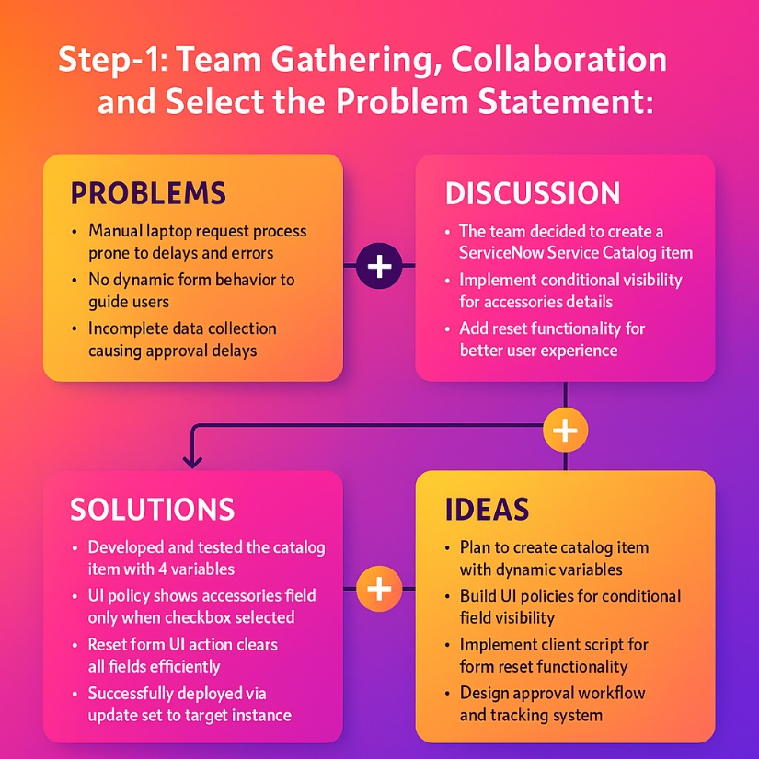

Step-2: Brainstorm, Idea Listing and Grouping:

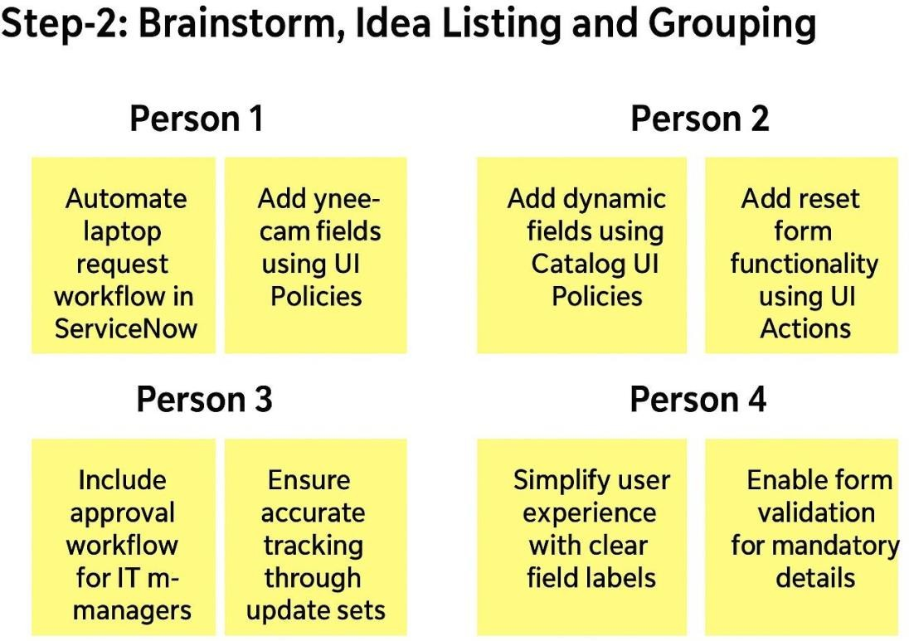

Brainstorm:
Team members discussed all possible ways to streamline the laptop request process using
ServiceNow’s features like catalog items, UI policies, and update sets.

Idea Listing:
All ideas were noted, including:
- Use of catalog variables for structured input.
- Dynamic visibility for accessories details.
- Implementing reset functionality using client script.
- Exporting configuration using update sets for easy migration.

Grouping:
Ideas were grouped under key modules:
- Form Design (Catalog item, variables)
- Dynamic Logic (UI policy, visibility control)
- User Experience (Reset button, clear feedback)
- Deployment (Update set, migration, commit process)

Action Planning:
Each module was assigned to team members to configure, test, and validate. Timelines were set to ensure smooth execution and integration.

Step-3: Idea Prioritization:

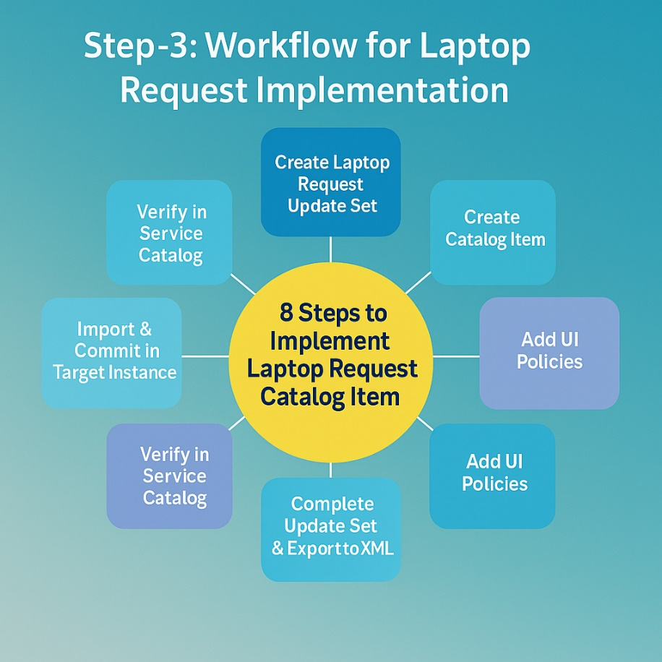

Idea Prioritization:
Prioritization was centered on fulfilling the organization’s key objectives — automating the laptop request process and ensuring precise data collection across all submissions.
The team’s primary focus areas included:
- Designing an intuitive and user-friendly form with well-structured input variables.
- Configuring dynamic form behavior to guide users efficiently based on their selections.
- Incorporating a reset functionality to enhance reusability and reduce user errors.
- Establishing deployment governance through update sets to maintain consistency across instances.
By strategically organizing and prioritizing these components, the team successfully developed a streamlined Laptop Request Catalog Item that enhances accuracy, saves time, and significantly improves IT service delivery. This well-structured approach promotes project clarity, enables rapid adaptation, and aligns seamlessly with ServiceNow’s ITSM best practices.

